English bridge - Copy

Home page

[x] Value statement (1 sentence, bilingual EN/SI):
EN: "Learn English on the go — built for Sinhala speakers with step by step guide."
SI: "ඉංග්‍රීසි ඉගෙන ගන්න, පියවරෙන් පියවර — සිංහල කතා කරන අයට විශේෂයෙන්."
(Native-speaker review needed on SI line before use.)

[x] Primary CTA label:
EN: "Check your level" SI: "ඔබේ මට්ටම බලන්න"

[x] How it works — step 1 (icon + short phrase):
Icon: level-check / target — "Take a 2-minute check to see where you stand"

[x] How it works — step 2 (icon + short phrase):
Icon: roadmap path — "Follow 8 steps, from tenses to formal letters"

[x] How it works — step 3 (icon + short phrase):
Icon: checkmark/feedback — "Practice and get instant feedback"

[x] How it works — step 4, optional (icon + short phrase):
Icon: streak flame — "Build a daily streak and watch your progress"

[x] "Why this exists" line (from Phase 0 purpose statement):
"Most English resources for Sinhala speakers are scattered or unstructured —
this gives you one clear path, with guidance in your own language, from
start to finish."

[x] "Not a textbook" block — line naming the fear:
"Not a textbook — a guided path."

[x] "Not a textbook" block — differentiator line:
"No random chapters to skim. Every lesson builds on the one before it,
starting with the mistakes Sinhala speakers make first."

[x] "Not a textbook" block — concrete outcome close:
"All the way to writing a real formal letter with confidence."

Placement page

[x] Intro line (sets expectation — length, no signup needed):
"Let's find your starting point. 6 quick questions, about 2 minutes.
No account needed — just answer honestly, there's no wrong way to do this."

[x] Question 1–6 (trimmed from 8 → 6, stage-mapped):
1. Which sentence is correct? "I eat rice" / "I rice eat" (Stage 1)
2. Fill the blank: "She ___ to school every day." — go / goes (Stage 1)
3. Which sentence uses "because" correctly? [two options] (Stage 2)
4. Fill the blank: "The book is ___ the table." — on / in (Stage 3)
5. Which sentence is passive voice? [two options] (Stage 4)
6. Translate: "මම පාසැලට යනවා" → type in English (Stage 5)
Each question includes a progress indicator ("Question 3 of 6") and a
"Not sure — skip" option.

[x] Result message template:
"You're ready to start at Stage [X] — [Stage Name]. [Encouraging line
naming what they already know before naming what's next]."

e.g. Stage 2: "You're ready to start at Stage 2 — Complex Sentences.
You've already got the basics of word order down. Let's build from there."

e.g. Stage 1: "You're ready to start at Stage 1 — Tenses. Everyone starts
somewhere. This is exactly where you'll build the strongest foundation."

[x] Post-result signup prompt copy:
"Save this so you don't lose it. Create a free account to start Stage [X]
and keep your progress, XP, and streak as you go."
Buttons: [ Create account ] [ Try a lesson first → ]

Sign up

[x] Framing line ("save your progress," not a hard gate):
EN: "Save your progress so it's here next time you come back."
SI: "ඔබේ ප්‍රගතිය සුරකින්න, ඊළඟ වතාවේ ආපහු එනකොට තියෙන්න."
(Native-speaker review needed on SI line before use.)

[x] Field labels (EN/SI):
Name — EN: "Your name" SI: "ඔබේ නම"
Email — EN: "Email address" SI: "විද්‍යුත් තැපැල් ලිපිනය"
Password — EN: "Create a password" SI: "මුරපදයක් සාදන්න"

[x] Submit button:
EN: "Save and continue" SI: "සුරකින්න, ඉදිරියට යන්න"

[x] Secondary option (per Phase 5 agency principle — never a hard gate):
EN: "Continue without an account" SI: "ගිණුමකින් තොරව ඉදිරියට යන්න"

Road map

[x] Stage 1–8 titles (EN/SI):
1. Tenses — කාල වචන
2. Complex Sentences — සංකීර්ණ වාක්‍ය
3. Adjectives, Adverbs & Prepositions — විශේෂණ, ක්‍රියා විශේෂණ සහ නිපාත
4. Passive Voice — කර්ම කාරකය
5. Sinhala–English Translation — සිංහල–ඉංග්‍රීසි පරිවර්තනය
6. Guided Essays — මඟපෙන්වූ රචනා
7. Solo Essays — ස්වාධීන රචනා
8. Formal Letters — විධිමත් ලිපි
(Native-speaker review needed — these are direct/literal translations, not
yet checked for natural phrasing.)

[x] Locked-state label:
EN: "Locked" SI: "අගුළු දමා ඇත"
Secondary microcopy (on tap): "Complete Stage [X-1] to unlock"

[x] In-progress-state label + % format:
EN: "In progress — [X]% complete"
SI: "ක්‍රියාත්මකයි — [X]% සම්පූර්ණයි"
e.g. "In progress — 60% complete"

[x] Completed-state label:
EN: "Completed" SI: "සම්පූර්ණයි"
Secondary microcopy: "Tap to review"

[x] XP header value format:
"[number] XP" e.g. "240 XP"
(No Sinhala needed — XP is a universal gamification term, safe to leave
untranslated per common practice on bilingual products.)

[x] Streak header value format:
EN: "[number]-day streak" SI: "දින [number] අඛණ්ඩව"
e.g. EN: "7-day streak" SI: "දින 7 අඛණ්ඩව"

Lesson

[x] Stage number + title (EN/SI):
Stage 1 — Tenses
අදියර 1 — කාල වචන

[x] Explanation (Sinhala-medium):
"ඉංග්‍රීසි වාක්‍යයක වචන අනුපිළිවෙල සිංහල භාෂාවට වඩා වෙනස්. සිංහලෙන් අපි
'මම බත් කනවා' කියනවා — කර්තෘ, කර්ම, ක්‍රියා පදය (Subject-Object-Verb)
අනුපිළිවෙලට. නමුත් ඉංග්‍රීසියෙන් අපි කියන්නේ 'I eat rice' — කර්තෘ, ක්‍රියා
පදය, කර්ම (Subject-Verb-Object) අනුපිළිවෙලට."
(Native-speaker review needed before use.)

[x] Worked example sentence(s) (EN with SI gloss):
I eat rice. → මම බත් කනවා (S–V–O)
She reads a book. → ඇය පොතක් කියවනවා (S–V–O)
We watch movies. → අපි චිත්‍රපට බලනවා (S–V–O)

[x] Sinhala↔English contrast callout:
⚠️ Common mistake: Sinhala speakers often write "I rice eat" by translating
Sinhala word order directly. Remember: in English, the verb always comes
right after the subject — never at the end.

Exercise

[x] Question text (example 1 — multiple choice):
"Which sentence has the correct word order?"
Options: (a) "I rice eat" (b) "I eat rice" (c) "Rice I eat"

[x] Question type: Multiple-choice

[x] Correct answer: (b) "I eat rice"

[x] Instant feedback banner (correct):
"Correct! Subject → Verb → Object — that's the English pattern."

[x] Instant feedback banner (incorrect) + correct-answer reveal:
"Not quite. In English, the verb comes right after the subject: I eat rice."

---

[x] Question text (example 2 — gap-fill):
"Complete the sentence: 'We ___ English every day.'"
Options: watch / watches / watching

[x] Question type: Gap-fill

[x] Correct answer: watch

[x] Instant feedback banner (correct):
"Correct! 'We' takes the base form of the verb."

[x] Instant feedback banner (incorrect) + correct-answer reveal:
"Almost — with 'we,' use the base verb form: We watch English every day."

Guided writing
[x] Prompt:
"Write a short paragraph about plastic pollution in Sri Lanka. Explain the
problem and suggest one solution."
(SI): "ශ්‍රී ලංකාවේ ප්ලාස්ටික් දූෂණය පිළිබඳ කෙටි ඡේදයක් ලියන්න. ගැටලුව
පැහැදිලි කර, විසඳුමක් යෝජනා කරන්න."

[x] Idea bank / fact sheet (3–4 bullets):
- Sri Lanka generates about 1.6 million tonnes of plastic waste every year.
- Much of it ends up in rivers and eventually the ocean, harming marine life.
- Many shops and markets have started charging for plastic bags to reduce use.
- Some communities now run weekly clean-up drives on beaches and canals.

[x] Outline scaffold:
1. Introduction — state the problem in one sentence
2. Explain why it matters (impact on environment / daily life)
3. Give one specific example or fact
4. Suggest one solution
5. Closing sentence — restate the main idea

[x] Sentence starters / connective word bank:
Opening: "One major problem in Sri Lanka is..."
Adding detail: "In addition, ... / Furthermore, ..."
Contrast: "However, ... / On the other hand, ..."
Cause/effect: "As a result, ... / This means that..."
Suggesting: "One solution would be to... / To solve this, we could..."
Closing: "In conclusion, ... / Overall, ..."

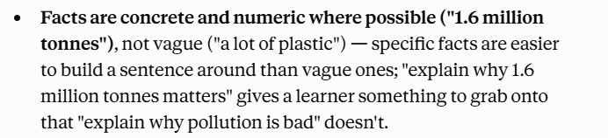

Solo writing

STAGE 7 — SOLO ESSAY

[x] Prompt:
"Write a letter explaining a problem that happened yesterday, what you are
doing right now to fix it, and why the original problem occurred."
(SI): "ඊයේ සිදු වූ ගැටලුවක් පැහැදිලි කරමින්, එය විසඳීමට ඔබ දැන් කරන දේ,
සහ එම ගැටලුව ඇති වූයේ ඇයි කියා ලියන්න."

[x] Self-assessment rubric — structure:
☐ Did I include an introduction, a middle section, and a conclusion?
☐ Does each paragraph stick to one main idea?

[x] Self-assessment rubric — grammar:
☐ Did I stick to the correct tense throughout, without accidentally switching?
☐ Can I highlight at least three complex sentences using because, although,
or if?

[x] Self-assessment rubric — vocabulary:
☐ Did I avoid repeating the same word more than twice? (try a synonym)
☐ Did I use at least one preposition correctly from Stage 3 (on, in, at,
depends on)?

[x] Self-assessment rubric — task fulfilment:
☐ Did I answer all three parts of the prompt (past problem, current action,
cause)?
☐ Did I use the passive voice at least once for a formal statement?

---

STAGE 8 — FORMAL LETTER

[x] Prompt:
"Write a formal letter to your English teacher explaining why you missed
an important class, and what steps you are taking to catch up."
(SI): "වැදගත් පන්තියකට නොපැමිණීමට හේතුව සහ එය පියවා ගැනීමට ඔබ ගන්නා ක්‍රියාමාර්ග
පැහැදිලි කරමින් ඔබේ ඉංග්‍රීසි ගුරුවරයාට විධිමත් ලිපියක් ලියන්න."

[x] Self-assessment rubric — structure:
☐ Does my letter have a clear opening, body, and closing?
☐ Did I use a formal greeting and sign-off (Dear... / Yours sincerely)?

[x] Self-assessment rubric — grammar:
☐ Did I use reference words (this, these issues, such problems) to connect
sentences instead of leaving them isolated?
☐ Did I stay in a consistent tense throughout?

[x] Self-assessment rubric — vocabulary:
☐ Did I avoid casual phrases? (e.g. "I want to talk about..." →
"I am writing to discuss...")
☐ Did I use at least one logical link word (therefore, as a result,
consequently)?

[x] Self-assessment rubric — task fulfilment:
☐ Did I clearly explain both the reason and the solution, not just one?
☐ Does the tone stay formal and respectful throughout, not casual?

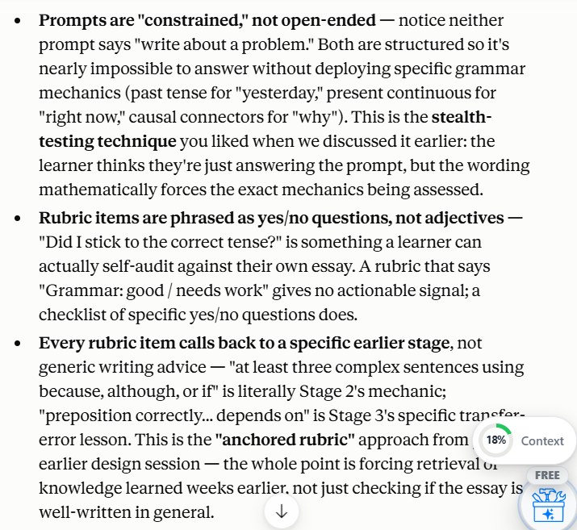

Progress/profile

[x] XP total display:
"[number] XP total" e.g. "1,240 XP total"
Subtext: "Earned across [X] stages"

[x] Streak display:
"[number]-day streak" e.g. "12-day streak"
Subtext (if streak is active): "Keep it going — come back tomorrow"
Subtext (if streak broken): "Start a new streak today"

[x] Per-stage completion %:
"Stage [X]: [Y]% complete"
e.g. "Stage 1: 100% complete" / "Stage 2: 60% complete" / "Stage 3: Locked"

[x] Overall course completion:
"[X] of 8 stages complete — [Y]% of the course"
e.g. "2 of 8 stages complete — 25% of the course"
Subtext: "[Z] stages to go until your certificate" (if FR-PG-05 is built)

Parent dashboard

[x] Header framing line:
"How [Child's name] is doing"
Subtext: "A quick look at their learning — not a report card."

[x] XP summary (read-only):
"[number] XP earned this week" e.g. "180 XP earned this week"
Subtext: "[number] XP total"

[x] Streak summary (read-only):
"[number]-day streak" e.g. "5-day streak"
Subtext (if inactive 2+ days): "Hasn't practiced in [X] days —
a gentle reminder might help"

[x] Stage completion summary (read-only):
"Currently on: Stage [X] — [Stage name]"
"[Y] of 8 stages complete"

[x] Supportive-role microcopy (added — not in original template):
"The best way to help: ask what they learned today, not how much they
scored."

[x] Privacy/reassurance note (added — not in original template):
"This view only shows progress, not individual answers or mistakes.
[Child's name]'s practice stays private."

